Linus Torvalds: A Biography

Linus Benedict Torvalds was born in Helsinki in 1969. He attended University of Helsinki and graduated with an MSc in computer science from the NODES research group. Certain mandatory national military requirements lead to Torvalds joining the Finnish Army Uusimaa brigade during his initial college years and he held the position of Second Lieutenant in the brigade. He returned to university to write his thesis “Linux: A Portable Operating System”. Torvald was interested in computers, programming in particular, from an early age. He began coding at the age of 11 in BASIC language to begin with. Torvald was forced to write his own assembler and editor for his devices because of the difficulties involved in obtaining certain software in Finland. During his college years Torvalds greatest interest in computer science was in the line of operating systems.

When Torvald graduated, it was evident that there was demand for a new operating system. The UNIX and MINIX systems lacked accessibility and had many limitations. As a result, programming groups from all origins set about developing a new operating system. In 1983, the GNU project was started with the aim of creating a free operating system similar to UNIX. One part of the GNU software, the kernel, did not reach expectations and so the project was left at a standstill. Torvald, who had a great deal of knowledge on the subject, began to develop his own kernel. He completed his kernel and released it to the public, but what he didn’t expect was the reaction that his software would receive. Soon Torvald was gaining help from hundreds of other developers who saw potential in his work. Because of the fact that Torvald had managed to release the kernel under the newly created GNU General Public License, many experienced and professional developers joined his community and the Linux kernel was then released as part of Yggdrasil Linux/GNU/X.

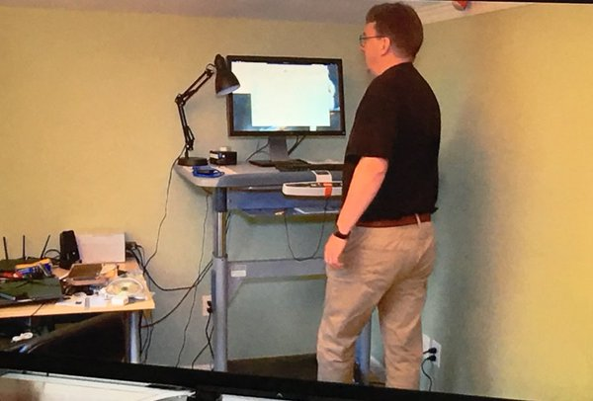

Adjacent is Torvald in the Linux “Global Headquarters” in his home office. This is where the initial system was created, along with help from the programming community. It contains one computer, a walking desk and a display of tangled wires. Below is a simplistic diagram of the main components of the Linux operating system.

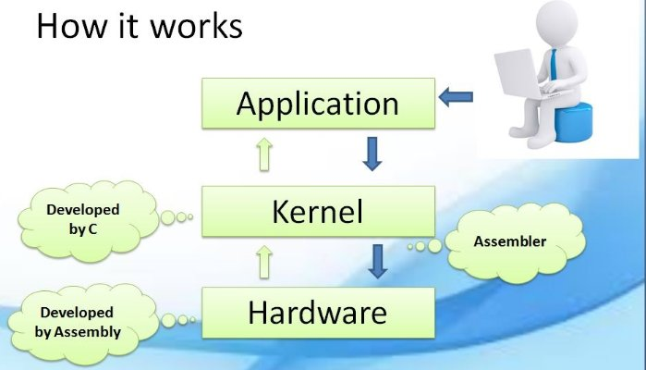

*The Impact of Linux*

Unlike many other operating systems, Linux is an open-source platform, which means that it is free. From humble beginnings in the office of a home in Helsinki, the Linux kernel and operating system is now used all over the world. Each update of the kernel has been worked on by over 1000 contributors from 100 different companies. As a result, the operating system has been hugely influential in the world of IT. The first and most obvious example of the impact of the Linux kernel is the smartphone. Each Android smartphone in the world contains the Linux kernel. Today, 87% of smartphones are powered by Linux operating systems (haydenjames.io). Android are beginning to dominate the industry as a result of the power of the Linux operating system. Apple have not been able to compete with the performance of the Linux OS and have fallen behind because of this.

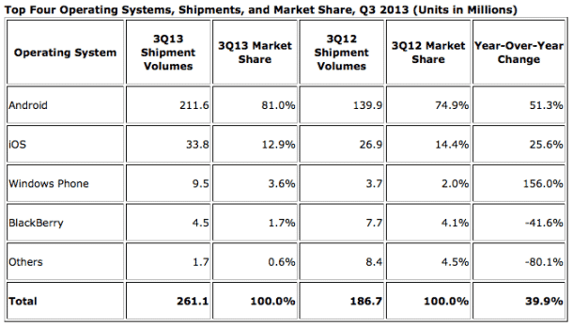

This table clearly shows Android’s dominance in the Smartphone Industry, which is fuelled by Linux.

Another example of the impact of Linux is the freedom it has brought to software developers all over the world. This open-source technology allows people of all origins to experiment with various opportunities and possibilities. The personalisation options that Linux devices offer compared to Windows and Mac are countless. This, in turn, creates a knock-on effect as these users are incentivised to give back to the operating system and add further features. Linux encourages developers to be creative and doesn’t limit their capabilities or imagination with much rules and regulations.

In addition, it is clear that Linux has paved the way for other operating systems in regards to its accessibility. A great amount of the features that we take for granted in Windows and OS X devices all originate from Linux and its open source community. Desktop spaces, 3D desktop virtualisation and other features were all first found on Linux (Lockergnome.com). Although maybe not as aesthetically pleasing as Windows or OS X, Linux has been the driving force behind many aspects and other operating systems would have found difficulty in producing these features if not for the influence of Linux.

Although the World Wide Web was only beginning its journey at the time that Torvald developed the Linux kernel, he must be amazed at just how much of the web is powered by Linux. Network administrators use Linux because of the amount of personalisation available to the network. It is a very efficient operating system and can run multiple tasks without clogging up the system. As a result of this, along with the other examples, it can be said that Torvald’s kernel and the supporting operating system have been very influential throughout this century and will continue to be influential for the foreseeable future.

*Git*

One of Torvald’s major issues when developing the Linux kernel was source control management (SCM). When Torvald began to share his code with others it became more tedious than he had expected. He found that the most suitable for his line of work was BitKeeper, but even this SCM had its faults. In 2005, Torvald then decided to create his own SCM system and within 10 days, he had developed Git. This project took all the positives from BitKeeper, such as the option of local repositories, and added to it with features such as optimized merging. Git also made it far easier to start a new project. With this new source code management, Torvald, along with the programming community, continued to work on the Linux kernel and the rest is history.

Torvald was extremely surprised to see how much interest had been attracted by Git. Although it was only created to allow easier accessibility to the Linux kernel source code, many developers began to see the benefits of using Git as an SCM and it soon became the most popular source control management system in the world. Git has reinvented the art of collaborative software development and this has been monumental in the development of Linux, but also in the development of millions of projects since.

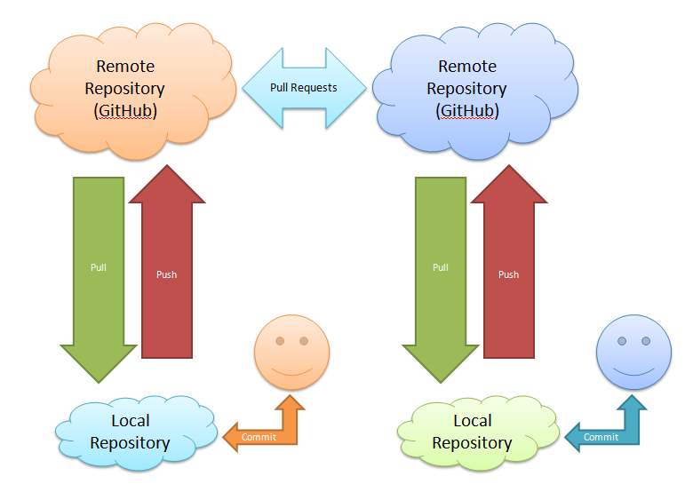

After spending his life in Helsinki, at the age of 28 Torvald decided to move. To no surprise, companies were lining up to offer positions to Torvald and he was swooped up by Transmeta Corporation. He worked as a commercial software developer and engaged in communications between operating systems and the company’s microprocessors. Torvald enjoyed many years working modestly before being offered shares in other companies as gratitude for his work. His net worth soon rose to roughly $20 million. He now works on the Linux kernel full time for OSDL in Oregon. He and his family now live in Portland and Torvald has shown no signs of moving away from working on his beloved kernel and its operating system. In 2012, Torvald was inducted into the Internet Society’s (ISOC) Internet Hall of Fame, which proves furthermore of how important this software engineer has been for the IT industry and how influential his work has been, and will be, for many years to come.

**References**

1. “81% of all Smartphones are Powered by Linux”, 2013

Available at:

<https://haydenjames.io/81-percent-smartphones-powered-by-linux/>

1. “Five Ways Linux Impacts Our Daily Lives”, 2011

Available at:

https://lockergnome.com/2011/09/30/five-ways-linux-impacts-our-daily-lives/#comment-84832

1. “How Linux/Unix Works”, 2016

Available at:

<https://www.linkedin.com/pulse/how-linuxunix-works-hossam-moghazy>

1. “The Plights of a Git Newb”, 2012

Available at:

<http://www.terminally-incoherent.com/blog/2012/05/07/the-plight-of-a-git-newb/>